1. project title- TCXXX

Insert your title here.

2. project modality

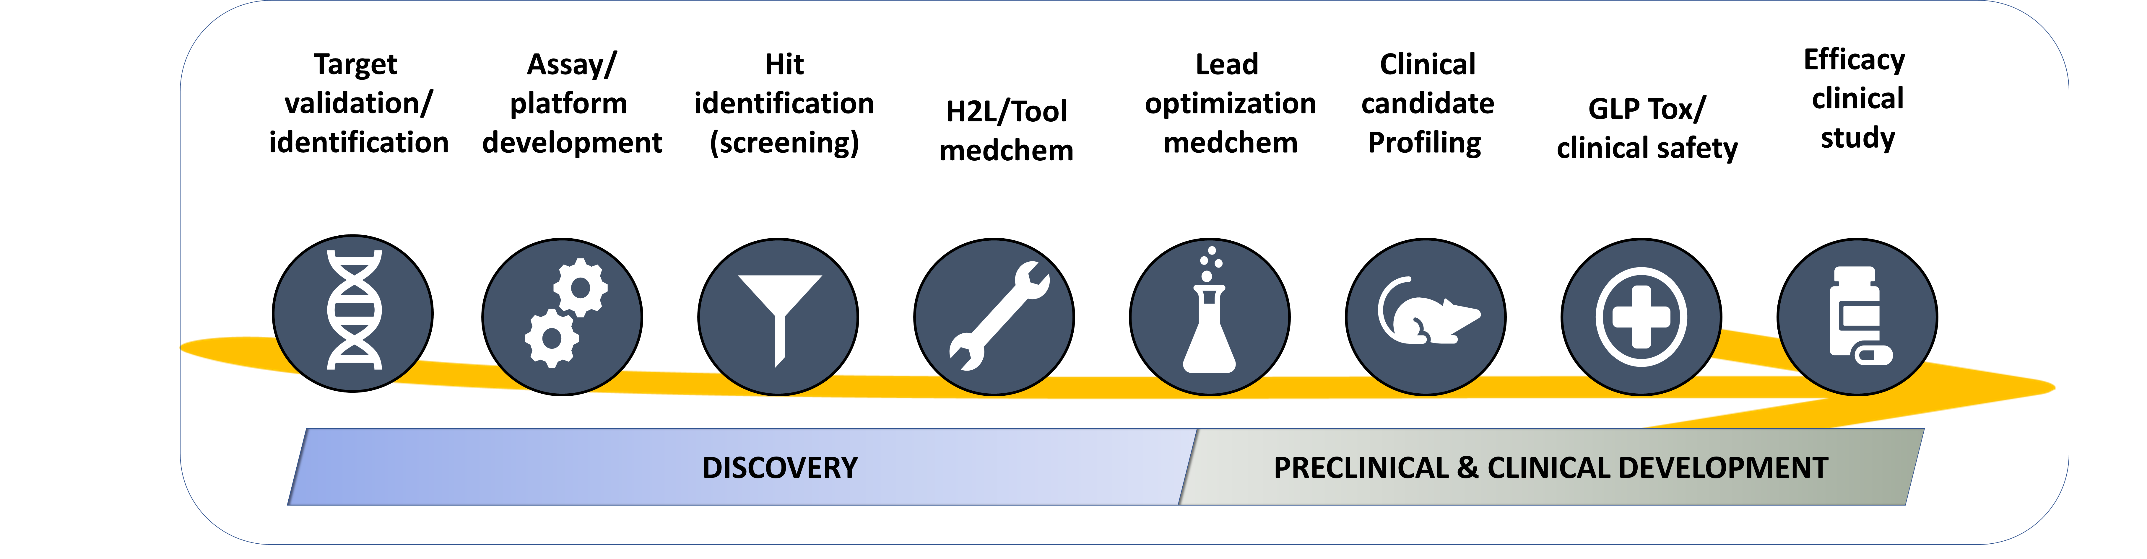

Specify the modality/modalities that apply to your project (specify as many as you need). See TCOLF funding schemes and project modalities description at the end of this document.

*Use Calibri 11 text format*

|  |
| --- |
| **STANDARD QUESTIONNAIRE FOR OPEN LAB - PROGRAMME EXTENSIONS** |
|  |

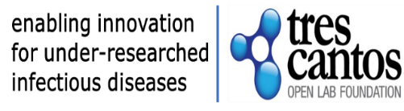

3. disease



Specify the disease. If other, specify

*Use Calibri 11 text format*

*.*

4. EXTENSION DETAILS

*Use Calibri 11 text format do not use bold. State here current end date and proposed end date and the type of extension*

Current end date:

Proposed end date:

Type of extension:

* Cost extension: additional funding request
* No cost extension: timelines only

6. work PLAN UPDATE

Split the work to be done in work packages. For clarity fill the Gantt chart template.

*Use Calibri 11 text format*

Work Package (WP) 1 –

Title, site, timelines

WP objective and tasks description:

Work Package 2 (if needed)-

Title, site, timelines

WP objective and tasks description

|  |  |  |  |  |  |  |  |  |  |  |
| --- | --- | --- | --- | --- | --- | --- | --- | --- | --- | --- |
| # WP | WP (short) name | months | | | | | | | | Site |
| 01-03 | 04-06 | 07-09 | 10-12 | 13-15 | 16-18 | 19-21 | 22-24 |
| WP1 |  |  |  |  |  |  |  |  |  | Home Institution |
| WP2 |  |  |  |  |  |  |  |  |  | GSK |
| WPn |  |  |  |  |  |  |  |  |  | other |
|  |  | |

5. JUSTIFICATION FOR THE EXTENSION REQUEST

Use this space to justify the rationale behind your request

*Use Calibri 11 text format, maximum 1000 words*

8. resources to be committed by applicant’s group

Use this space to enumerate contributions to the project at your home institution in-kind (estimated number of employees, consumables, etc.)

*Use Calibri 11 text format, maximum 200 words.*

7. how do you envisage gsk r&d contribution to the project?

Use this space to enumerate the benefits for your project to collaborate with industry (platforms, compound collection, scientific and technical expertise, etc).

Use Calibri 11 text format, maximum 200 words

9. additional questions

1. Does the project involve any research work with human biological samples, different to the original application? Y/N

If yes, do the human samples belong to the Home Institution?

If no, please specify source

1. Does the collaboration involve any research work with animals, different to the original application? Y/N

If yes, does the animal work will be performed at the Home Institution?

If no, please specify the facility location

10. budget

For Discovery projects: Accommodation during the stay in GSK Global Health R&D Spain will be provided and paid by a TCOLF external supplier, provided that the researcher relocates to one of the flats administered in Tres Cantos.

Open Access allowance up to £3,500 will be covered during Grant period and 12 months following completion of the project, 50% will be covered during the second year and 25% in the third year

|  |  |  |
| --- | --- | --- |
|  | ***Funding requested in GBP*** | ***Description of costs to be funded*** |
| **Personnel costs** |  |  | Maximum personnel costs funded will be of:   * Technician: £35,288 /year * Degree: £ 40,779/year * PostDoc: £ 53,565/year * PostDoc with >10 years post-doctoral experience: £ 62,110/year   Salary will be calculated deducting employer costs (social security contributions, life insurance if provided, etc) from this amount. |
| **Operations** |  |  | E.g. recruitment of participants, administrative costs, courier & shipping of materials, checkups, if needed |
| **Travel** |  |  | Travel to/from Home Institution location   * Project duration up to 7 months: one round trip for each of the visiting scientists and leader investigators. * Project duration over 7 months: two round trips for each of the visiting scientists and leader investigators   Reference for short-haul flights (within Europe) is £300 and for long-haul flights (outside Europe) is £1.000 |
| **Consumables** |  |  | Lab supplies at the home institution / GSK (please specify) |
| **Services** |  |  | Other research costs, e.g. subcontracting/CRO (please specify) |
| **Other costs**  **(specify)** |  |  | Dissemination related expenses such as conference fees, travel to conferences of funded scientists |
| **Subtotal**  **(Institution)** |  |  |  |
| **Accommodation** |  | Number of months in Tres Cantos  OL Fellow 1:  OL fellow 2: | Accommodation during the stay in GSK Spain will be provided and paid by the TCOLF, provided that the OL fellow relocates to one of the flats at Tres Cantos. |
| **Open Access** |  | Open Access allowance up to £3,500 will be covered during Grant period and 12 months following ing completion of the project, 50% will be covered during the second year and 25% in the third year | |

PROJECT MODALITIES

Projects on scope include innovative approaches in the field of endemic infectious diseases that could offer a new solution to an existing gap that can benefit from collaboration with the pharma industry in the fields of gut health (including bacterial enteric infections and environmental enteric dysfunction, EED), malaria, tuberculosis, and kinetoplastid mediated infections. In addition to discovery projects, since April 2019 TCOLF is accepting applications in the translational and clinical (up to Ph2a) space.

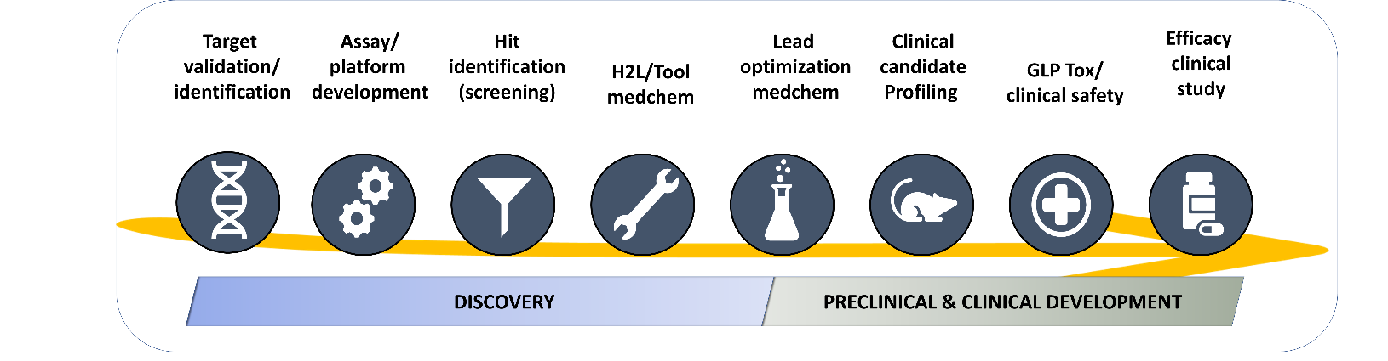

- Discovery Projects: Co-location is a key factor for eligibility. The maximum budget is expected to be ≤ £200K.

- Preclinical and Clinical Development projects: Co-location is not expected. Due to the greater anticipated cost of these projects, the scope will be restricted to: advanced lead molecules (robust *in vivo* activity on relevant models with a clear developable profile), clinical candidates, and repurposing opportunities. The maximum budget is expected to be ≤ £500K.

**Target validation / identification:** Projects on scope include generation of chemical probes for chemical validation of novel genetically validated targets and the use of chemoproteomic approaches for target identification/engagement.

**Assay / platform development:** Development and miniaturization of quantitative assays for screening (LTS, MTS, HTS) or medicinal chemistry programs.

**Hit Identification:** Screening campaigns of focus compound sets and / or diversity compound sets from the GSK collection.

**H2L / tool optimization:** Program focused on optimizing a molecule (*in vitro active* with none or poor *in vivo* activity) to deliver a selective (in the case of target base programs) advance analogue with a Pharmacokinetic compatible with an oral dosing for proof of concept in animal model (lead compound).

**Lead optimization:** Medicinal chemistry program focused on optimizing a lead/s molecule/s (*in vivo active*) to deliver a new analogue with a robust in-vivo efficacy subjected to full *in vivo* pharmacological profiling for the target indication and a tailored toxicological safety assessment to finally qualify as a clinical candidate. Depending on the candidate-likeness of the lead molecule, the project can be considered Discovery Projects or Preclinical & Clinical Development Projects

**Clinical candidate profiling:** Tailored plan to evaluate potential clinical candidates (small molecules, biologicals, etc). Projects on scope include non-GMP scale-up, tailored non-GLP *in vivo* preclinicalsafety and/or efficacy studies.

**GLP Tox / clinical safety:** Tailored plan to evaluate clinical safety of novel candidates (small molecules, biologicals, etc). Projects on scope include GMP scale-up, tailored GLP *in vitro* and *in vivo* safety studies and Clinical safety (Phase 1 studies)

**Efficacy clinical studies:** Tailored clinical Probe of Concept (Phase 2 studies).